Gym database

group 35
Mohamed 226791
Yussef 225720
Moataz 227450
Ziad 227631
Mohamed 223331



Domain: sports clubs
Scope: Gym
Description :
The gym database is concentrating on the gym and its functionalities where it follows the following scenario. The client enters the gym where he will choose a membership from various memberships included in the gym where he tries his best to find the perfect workout for their body where the gym fill a paper with their information and height and weight and all of the data that he fill along with the progress he achieve during his workout will put on a report .The gym has many trainers with different experiences and these trainers can help many clients with putting the best workout suitable for the client. The gym contains many supplements that the each client can purchase and limit their need of searching for supplements outside the gym. The gym has a very profitable deal with sponsors as many sponsors can supply the gym with many gym equipment like muscle machines and weights. All gym branch contains a lot of employess from these employes is the manager that can supervise many employees under his command and these employess works in different departments a lot of employees like the security where it provides a sense of safety to the clients and prevent any damage to the gym and the cleaners as each gymbranch contains a lot of rooms for clients to train on it that needs to be cleaned and the repairmen as the gym contains a lot of equipments that needs many repairman to maintain.

ERD :
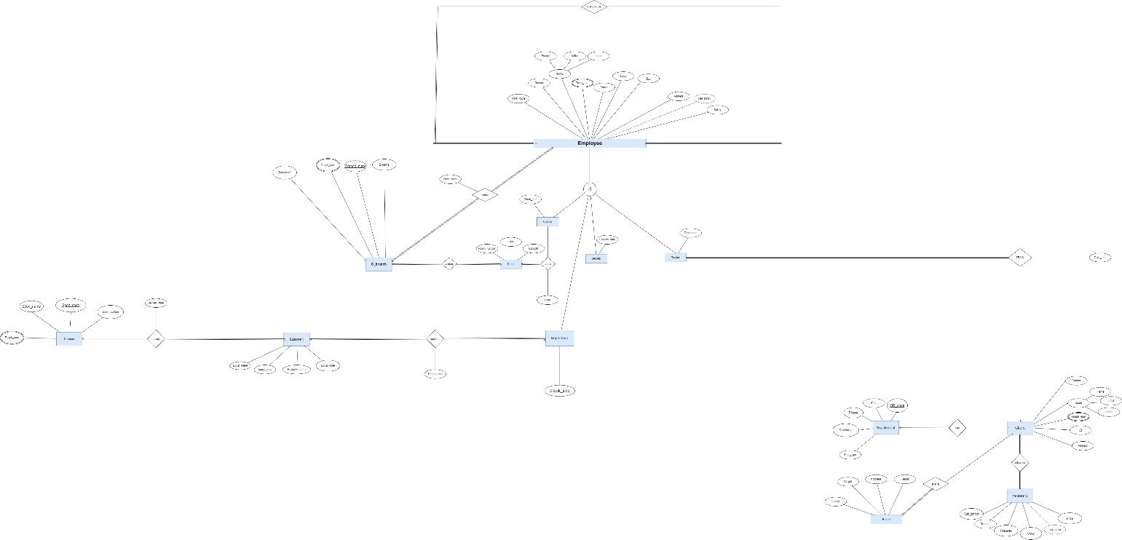

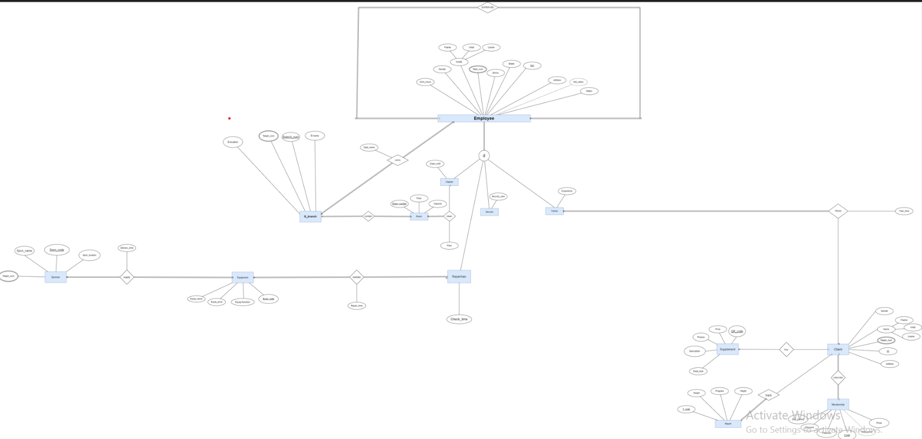

The images is not clear so it is better to view these images in the file we imported.

Schema :
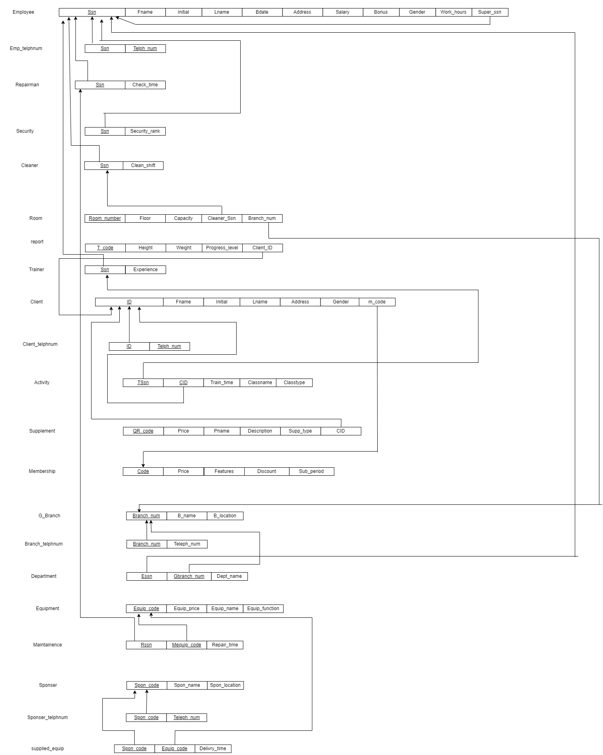
SQL file:


The queries:
Mohamed 226791:
1.For equipments whose function is strength the legs display its equipment code and equipment function and equipment price.
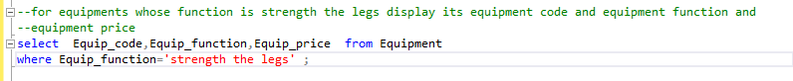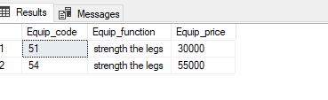
2. display a list of equipments with prices more than the average price.
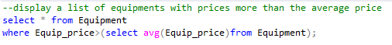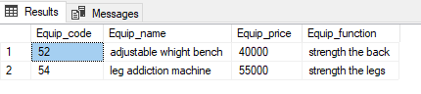
33. retrieve the spon_name and spon_location of sponsers that supply equipments except dumbels.
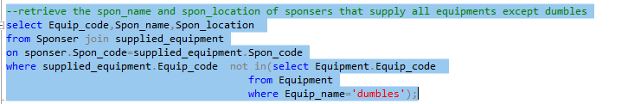
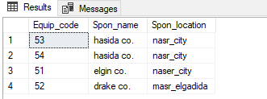

4.for clients , who bought more than 1 supplement display a list of their id and how many products they buy stored by the number of supplement they bought in descending order.
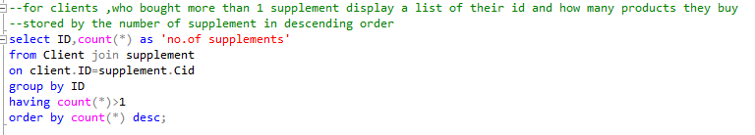
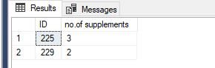
5. for clints who buy supplement select their first name and last name of them if the client didn’t buy any supplement there will be null values in the product name.
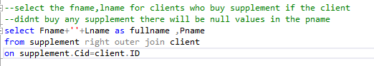
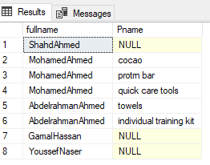
6. display the first name , and branch name and department name for the the employess who works on the g_branch that his name is elwadi . 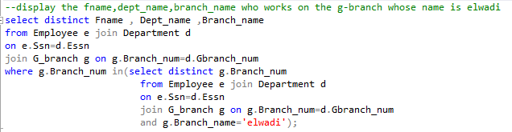
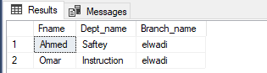
7.for clients who are males and their progress level is A select the fullname and gender and progress_level.
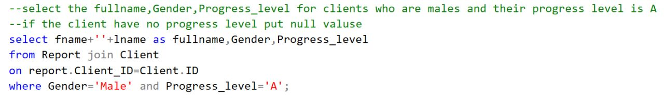
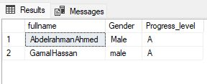
8. for trainer who train clients whose membership sub period is 3 months give me there ssn.
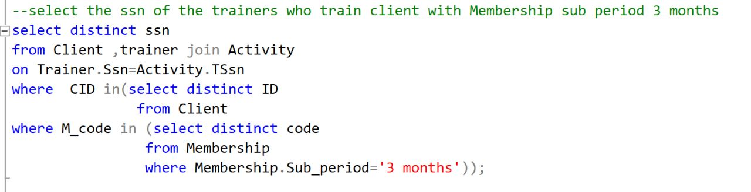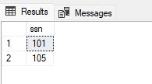

Moataz 227450:

1-Query 1: this is a calculated query to set the value of the subscription price of the client after the discount AS ‘Total Price’, distribute between price and discount (price-Discount).
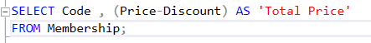
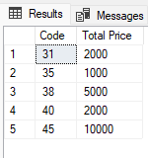
2-Query 2: this query to retrieve the maximum, minimum, and average Salary of the Employee.
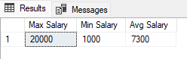

3-Query 3: this query will retrieve the Client ID,Fname ,Lname and the report T_code.
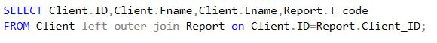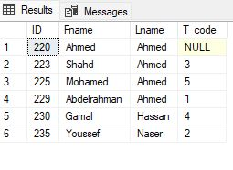

4-Query 4: this query to retrieve the number of trainers whose salary greater than 5000.
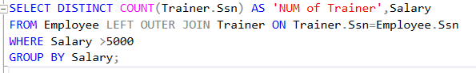
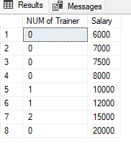
5-Query 5: this query to retrieve the Client ID, Fname, and Lname whose gender are Female.
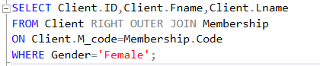
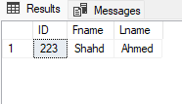
6-Query 6: this query to retrieve the Code and Price of the maximum price of table Membership.
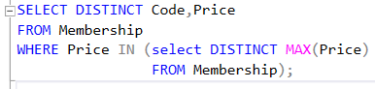
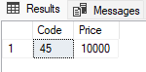
7-Query 7: this query to retrieve the Code of the Membership of the Client whose trainer name is ‘Mostafa’.
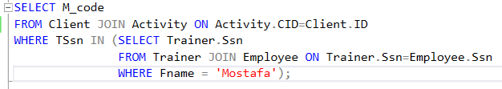
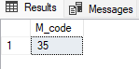
8-Query 8: this query to retrieve the client name and ID whose trainer experience is ‘Professional’.
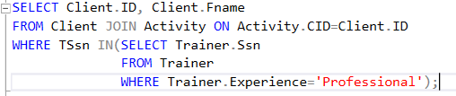
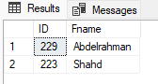

9-this is report for the employee whose salary <5000
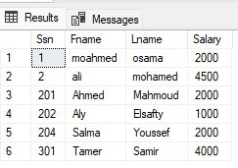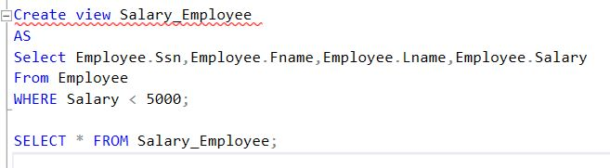
Youssef 225720:
1)This query calculates the Net salary by adding salary to the bonus
Code:
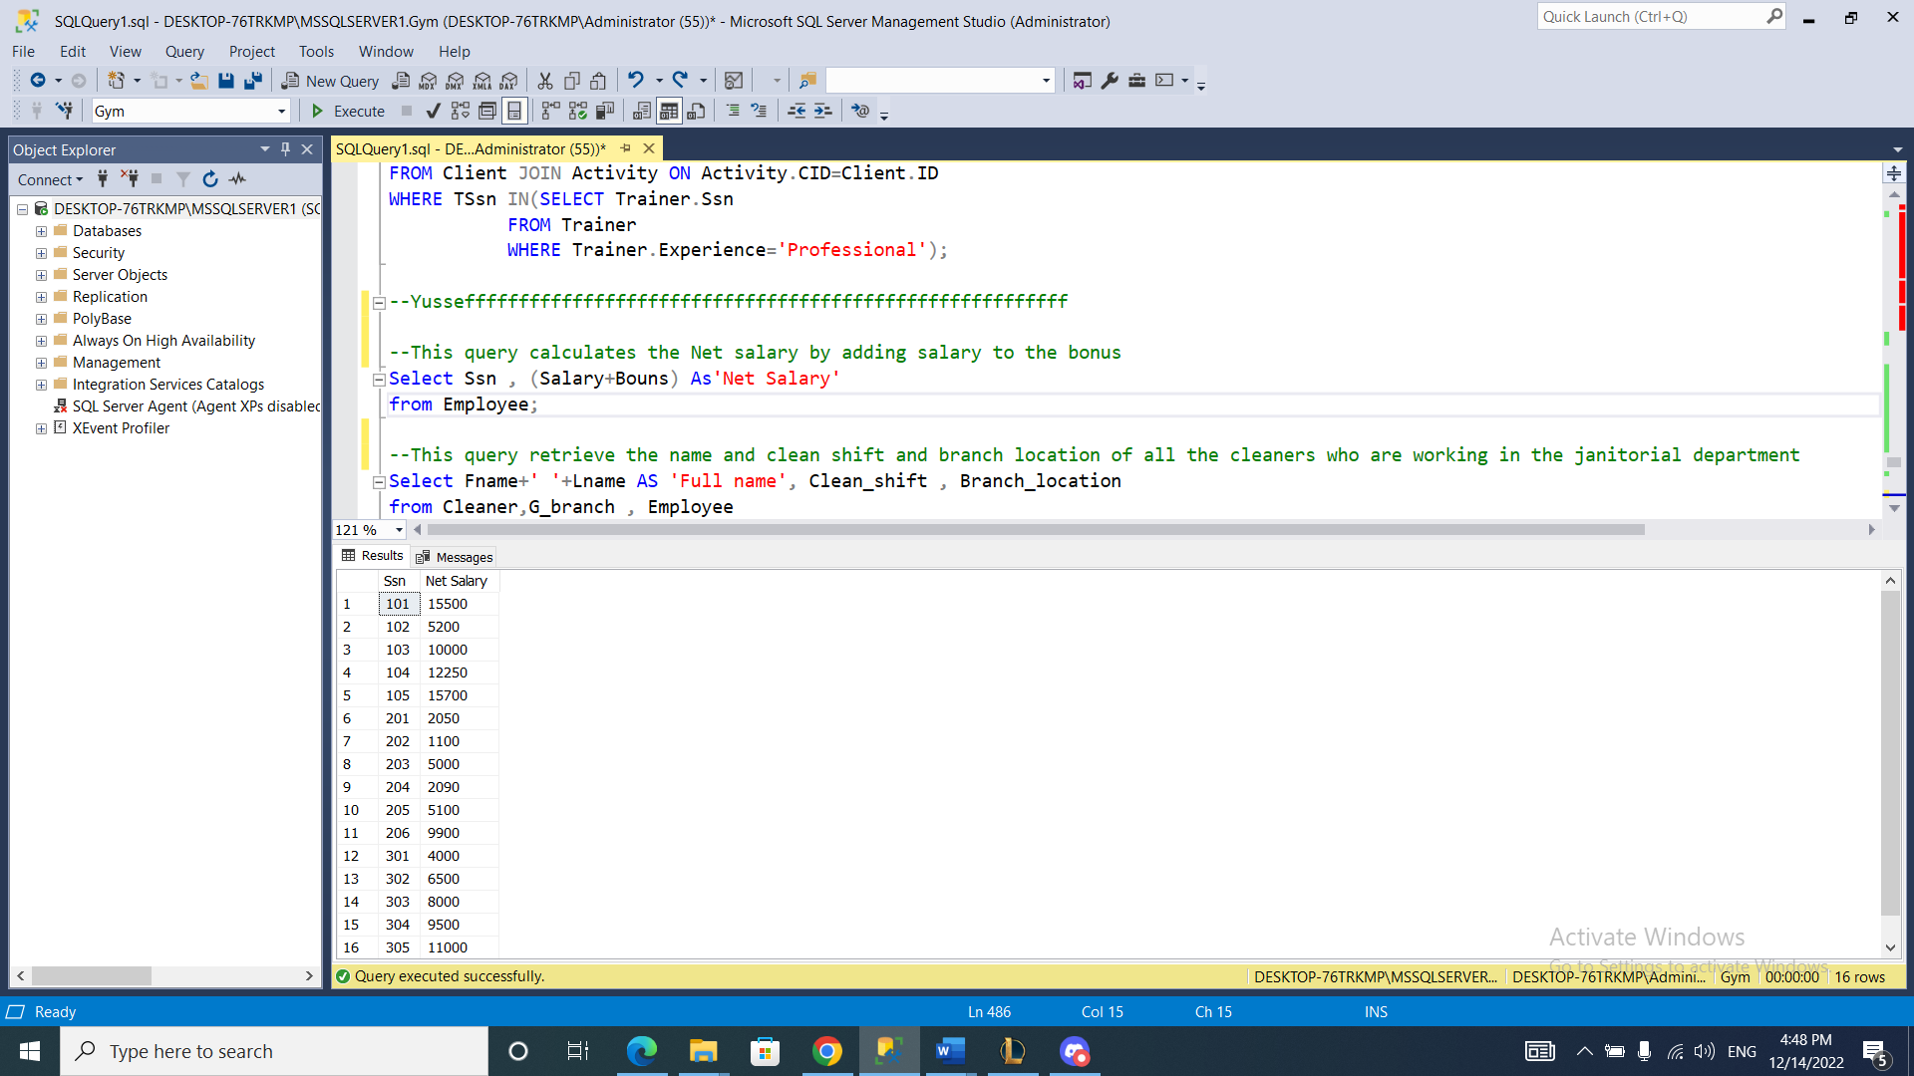
Result:

2)This query retrieves the name and clean shift and branch location of all the cleaners who are working in the janitorial department.
Code:
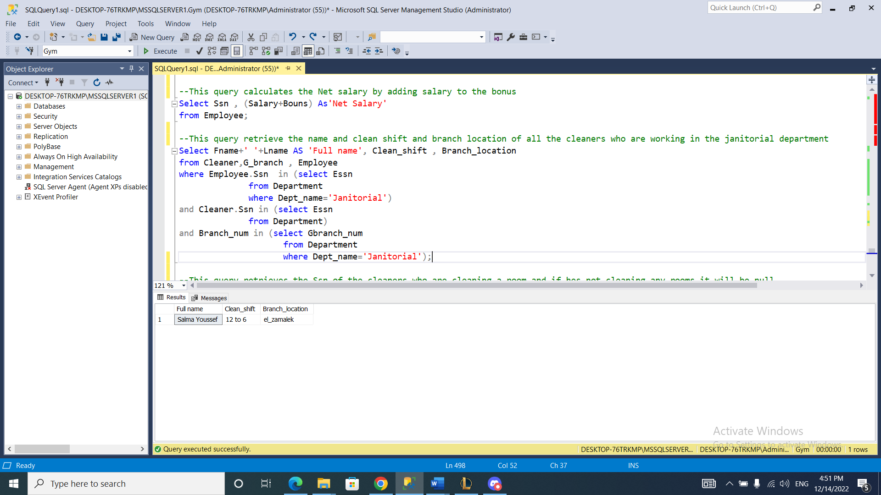
Result:

3)This query retrieves the Ssn of the cleaners who are cleaning a room and if he’s not cleaning any rooms it will be null
Code:
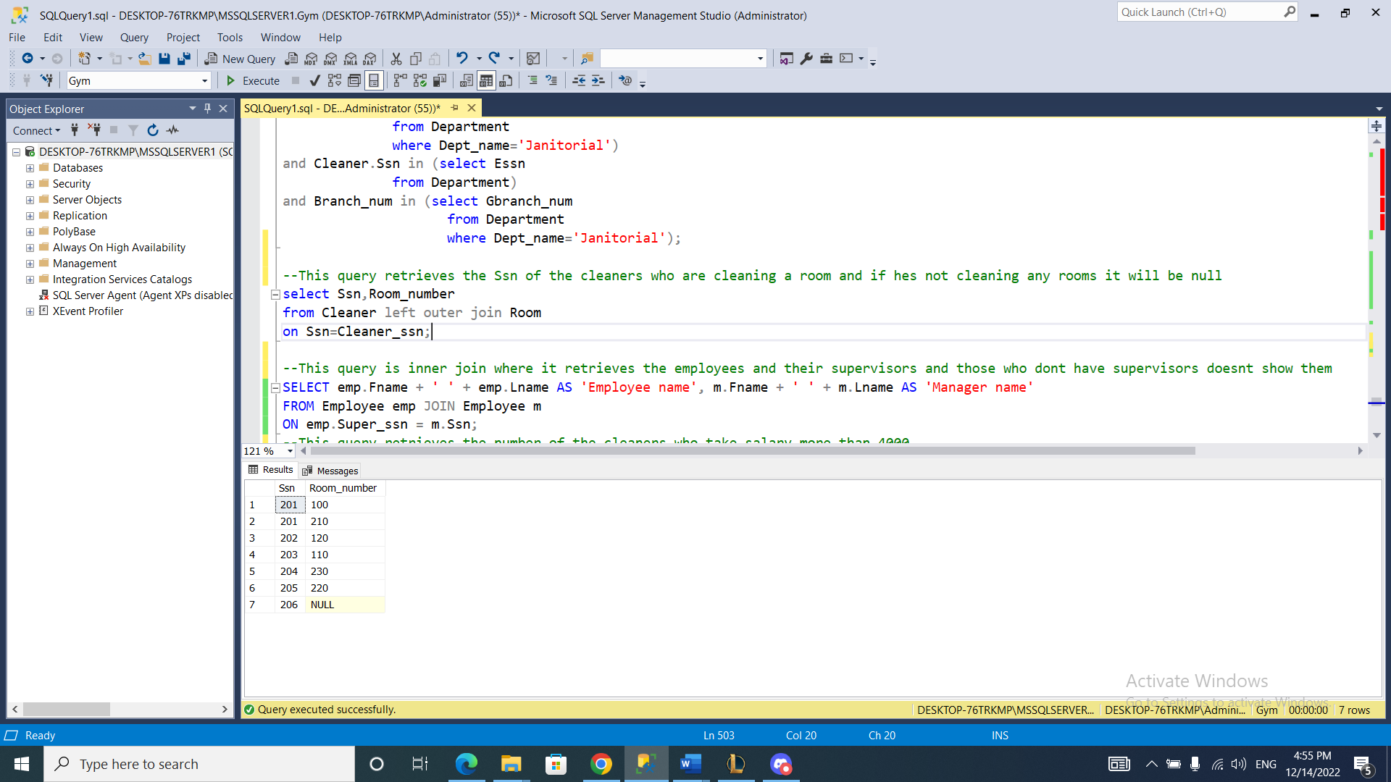
Result:
4)This query is inner join where it retrieves the employees and their supervisors and those who don’t have supervisors doesn’t show them
Code:
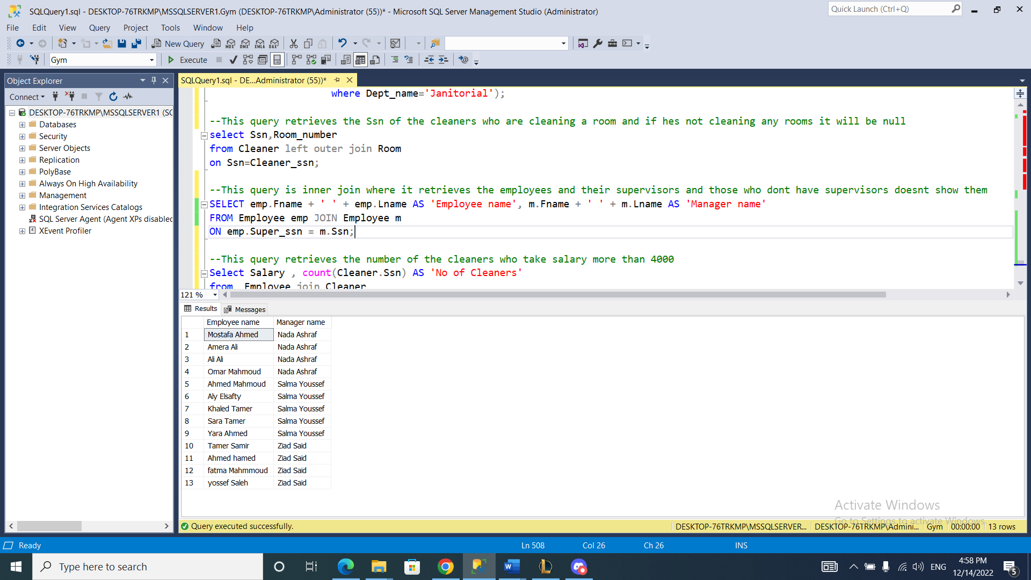
Result:
5)This query retrieves the number of the cleaners who take salary more than 4000
Code:
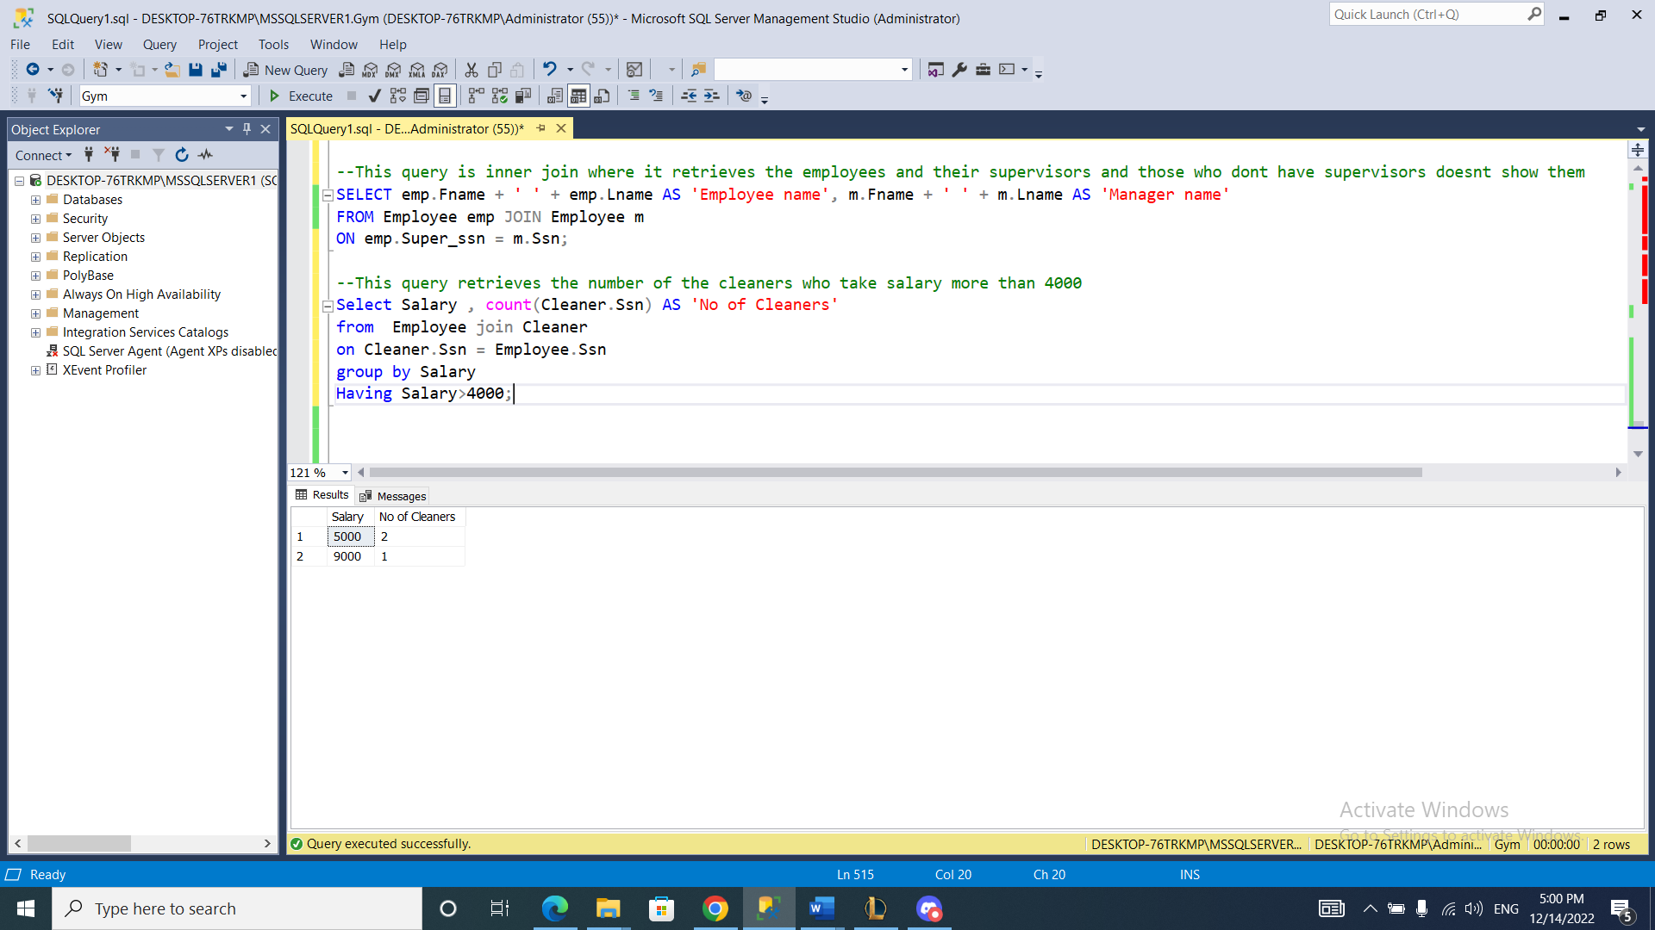
Result:

6) This query organizes the cleaners by name to make it easy to navigate them
Code:
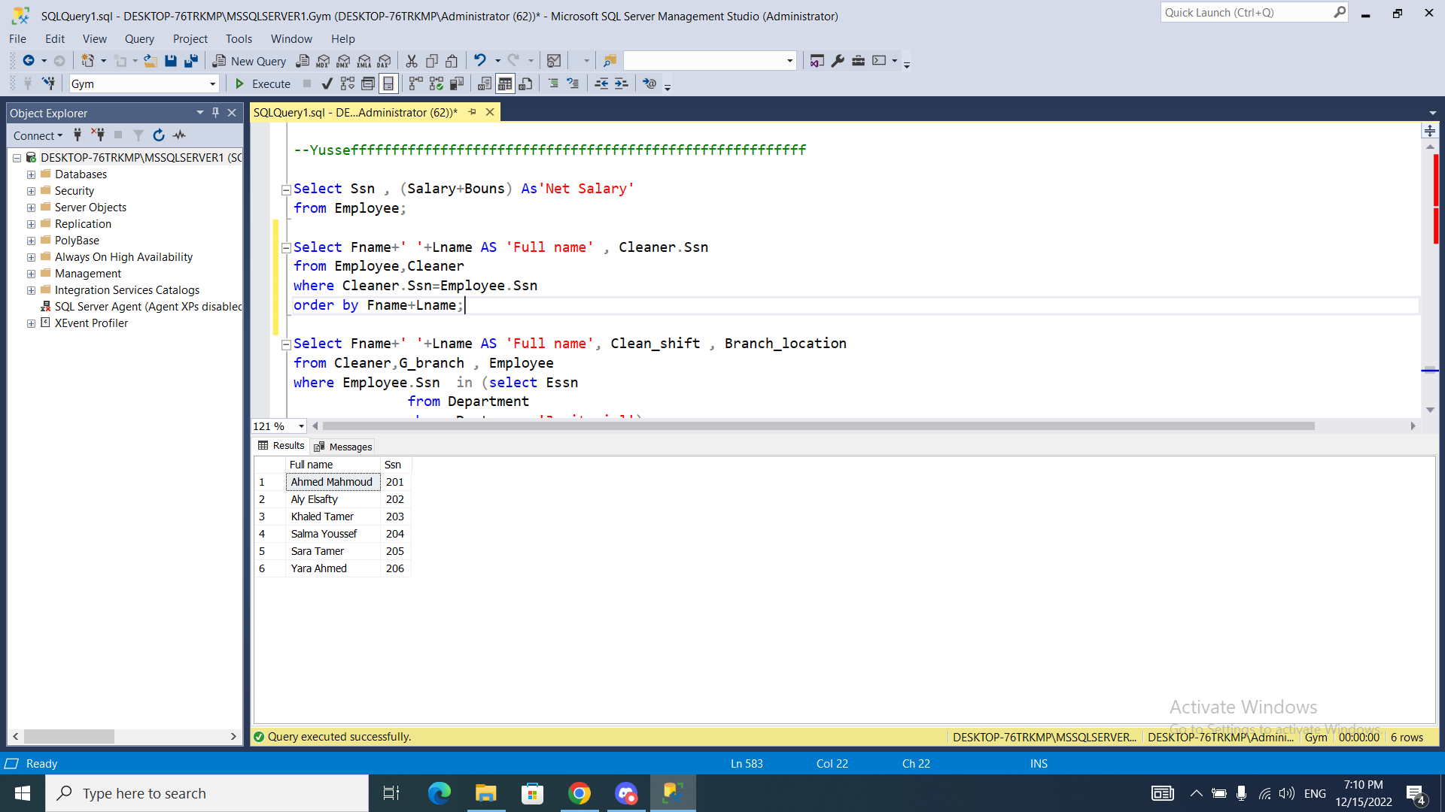
Result:

Mohamed wafiq 223331:

Retrieve the product name QR_code and price with a description has a word with this letters 'dri'

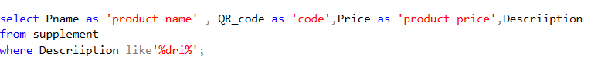
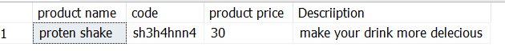

Retrieve the number of products with price more than 30

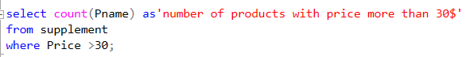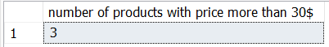

Retrieve first name and last name -with Concatenate both attributes together under one attribute called name- of an employee that check-time = 4:00:00
By using join
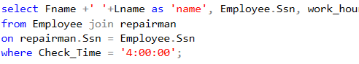
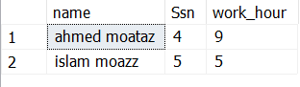

Retrieve Ssn meequip_code that has repair time 12:00:00
By using join and nested query

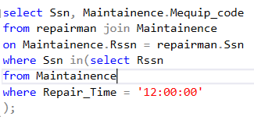
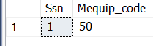

Retrieve first name and last name -in one attribute called employee name-
Of the employee who has the same salary of employee with Ssn 301

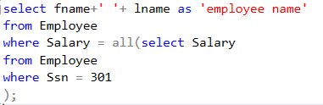
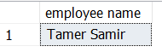
Retrieve first name and last name from (client table) and client id from(supplement table)
By using left outer join
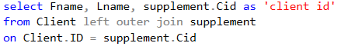
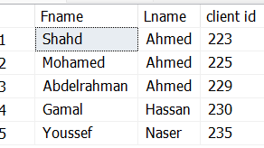

Ziad Mohamed 227631:

1- retrieve employees name whose salary less than 6000 to receive a Promotion.
Output:
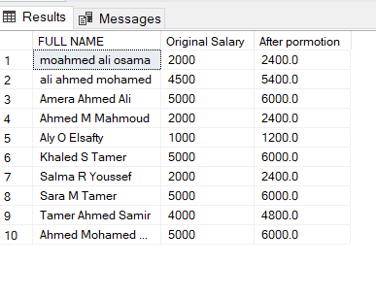
2-Retrieve employees who works more than 8 hours to increase monthly Bonus.
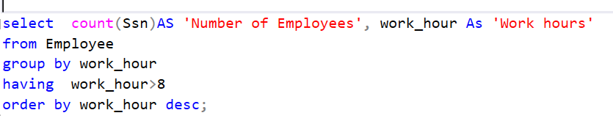
Output:
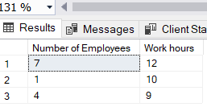

3-Retrieve clients who have high level progress to receive a discount.
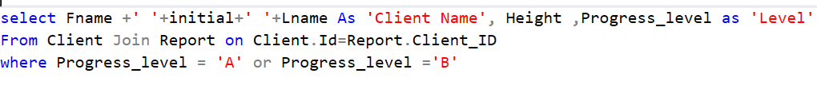
Output:
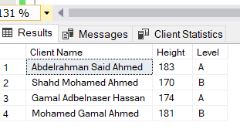
4-Retrieve rooms need expansion.
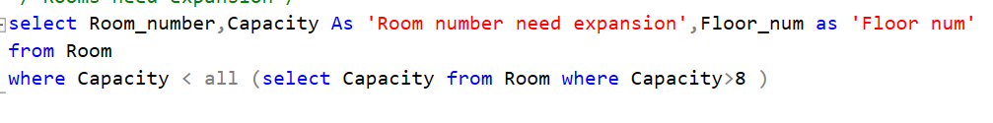
Output:
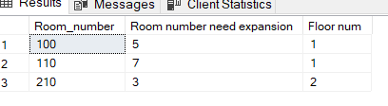
5-Retrieve equipment’s need to change for high price.
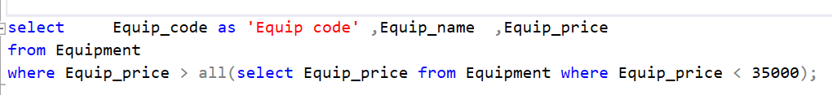
Output:
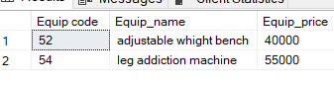

e-Discount).

